

Commercial Taxes Department Government of Tamil Nadu

Tamil Nadu VAT Implementation,
Guide for Home page
May, 2018
Version 1.0
Tata Consultancy Services TNVAT-Home page-User-Manual-V1.0

Contents

- New Home page screen 3

Tata Consultancy Services TNVAT-Home page-User-Manual-V1.0

New Home page screen

Home page contains menus, gives latest updates and various services to the taxpayers.

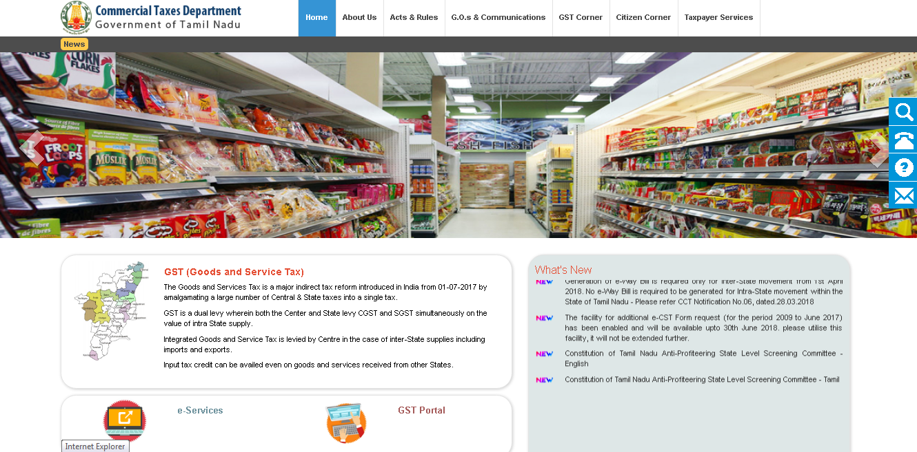

Menus in Home page:

Home menu:
Redirects to the home page screen.

About us menu:
Describes the vision & mission, organisation structure, policies and CT at a glance details.

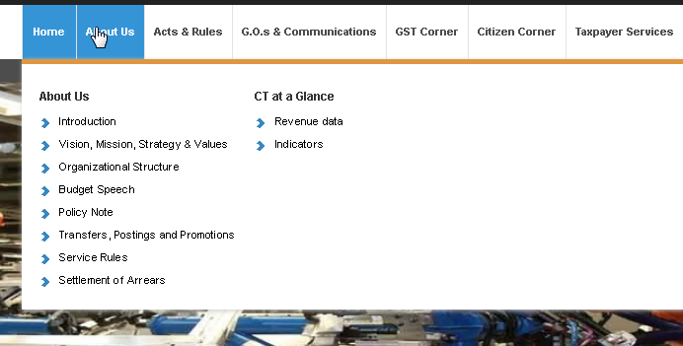

Tata Consultancy Services TNVAT-Home page-User-Manual-V1.0

Acts & Rules menu:

Describes acts and rules of different tax types.

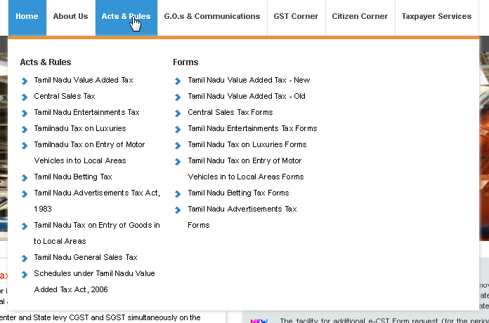

G.O&communications menu:

Contains department notifications and circulars

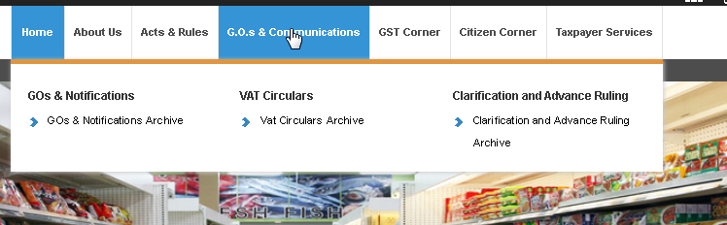

GST corner menu:
Provides Act& Rules of GST, Notifications from GST, GST user manual and GST rates for different services.

Tata Consultancy Services TNVAT-Home page-User-Manual-V1.0

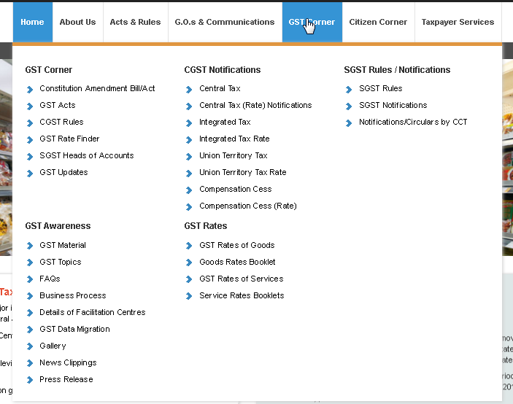

Citizen corner:
Provides Right to Information, latest tenders and auctions

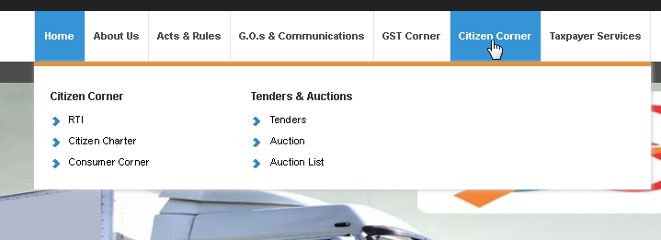

Taxpayer services:
Directs to TSP e-services (such as Registration, Returns, Payments, Forms generation) and GST portal.

Tata Consultancy Services TNVAT-Home page-User-Manual-V1.0

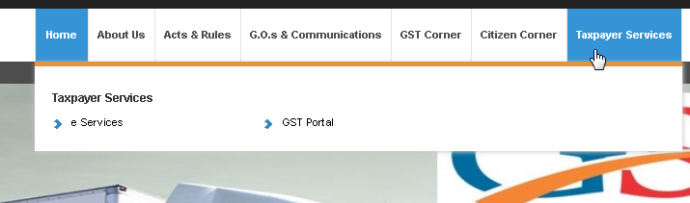
Scroll message : Messages to indicate taxpayers will be highlighted here as per below screen

What’s new menu:
Provides latest updates or notifications to the taxpayers

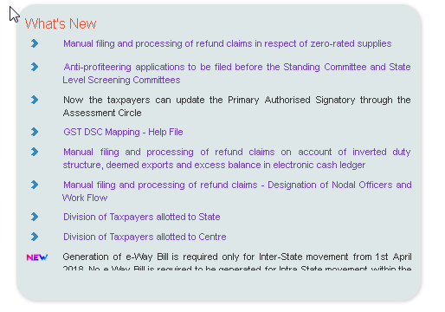

Other services:
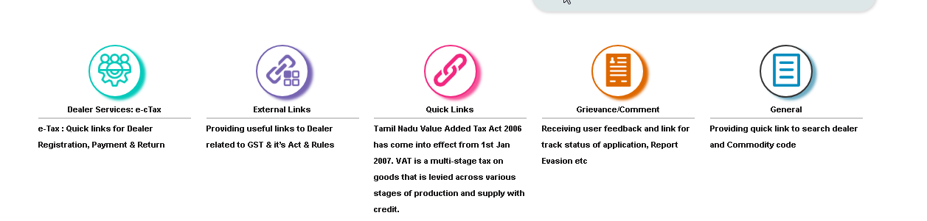

Tata Consultancy Services TNVAT-Home page-User-Manual-V1.0

Dealer services:
Provides links to different e-services such as Returns,Payments,Regitration and Forms generation.

External links:

Redirects to different government sites such as Service tax, TINXSYS , Traders Welfare board,GST enrollment status and Income tax department.

Quick links:
Provide links to different e-services templates,link for email and SMS verification code and resend password for taxpayers.

Grievance/Comment:
Taxpayer can log their request, track their application status, feedback and grievance redressal.

General:
Includes LTU dealers list, Cancelled dealers list , Tax rates of difference services and dealer search.

Icons available Right corner of Home page:

Search, Contact us, Helpdesk and Help icons are available for the taxpayers to get their concerns fixed.



Icons available Right corner of Home page:

Search, Contact us, Helpdesk and Help icons are available for the taxpayers to get their concerns fixed.

Tata Consultancy Services TNVAT-Home page-User-Manual-V1.0

Search:
Taxpayers can search the required details by entering in textbox and clicking on “Search” icon.

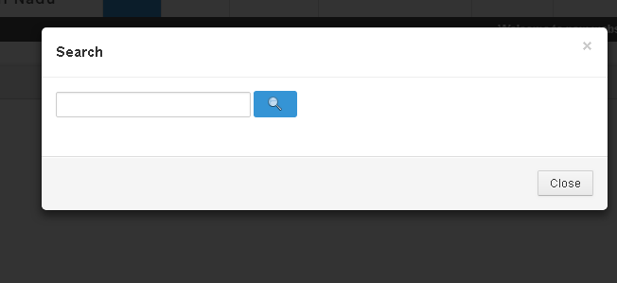

Helpdesk:

Display the contact number and mail of State helpdesk

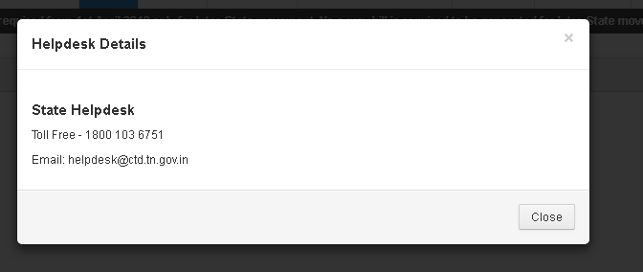

Help:
Display the reference documents of different e-services for the taxpayers

Tata Consultancy Services TNVAT-Home page-User-Manual-V1.0

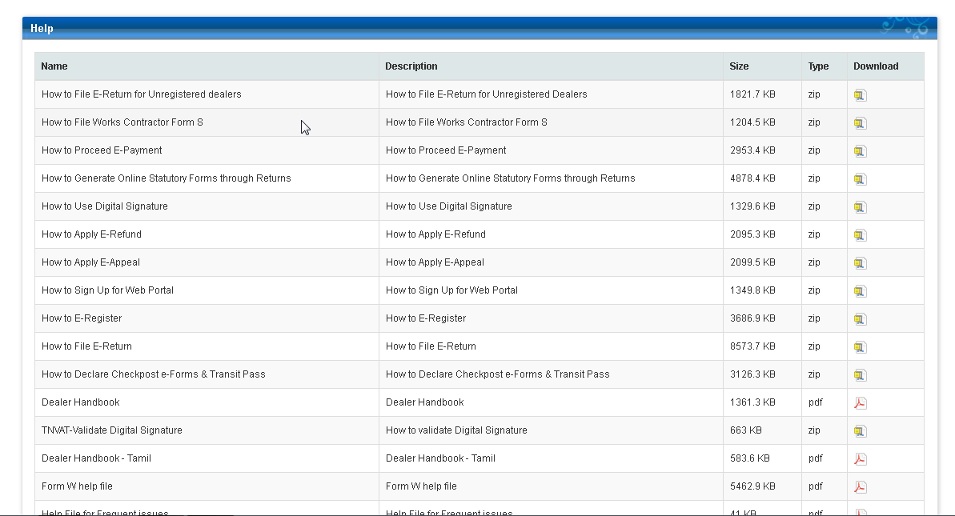

Contact us:

CTD officials contact details will be present in this screen and taxpayers can connect to the respective officials for any concerns.



